1. Write a Python function to calculate the factorial of a number (a non-negative integer). The function accepts the number as an argument.
2. Write a Python function that accepts a string and counts the number of upper and lower case letters.  
   Sample String : 'The quick Brow Fox'
3. Write a Python GUI program to import Tkinter package and create a window and set its title.

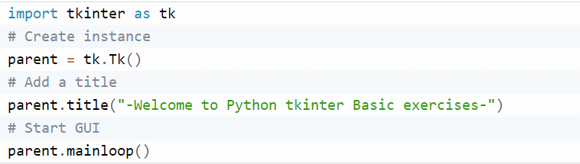

1. Write a Python GUI program to add a button in your application using tkinter module.

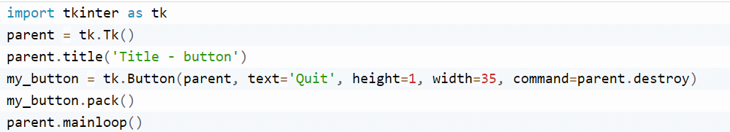

1. **A)** Write a NumPy program to print the NumPy version on your system.

B) Write a NumPy program to create a 3x3 matrix with values ranging from 2 to 10.  
Expected Output:  
[[ 2 3 4]  
[ 5 6 7]  
[ 8 9 10]]

1. Write a NumPy program to convert an array to a floating type.  
   Sample output:  
   Original array  
   [1, 2, 3, 4]  
   Array converted to a float type:  
   [ 1. 2. 3. 4.]
2. Write a Python program to create a calculator class. Include methods for basic arithmetic operations.
3. Python Program to find largest element in an array
4. Python Program to find yesterday’s, today’s and tomorrow’s date
5. Python Program to find difference between current time and given time
6. Python program to Count Uppercase, Lowercase, special character and numeric values using Regex
7. Count number of lines in a text file in Python
8. Write a python program to demonstrate GUI form.
9. Write a Python class to reverse a string word by word.
10. Write a Python class to implement pow(x, n).

1. Write a Python class to convert an integer to a roman numeral.
2. Python program to Plot the Histogram
3. Python Program to draw Bar Graphs For Data Visualization

|  |  |
| --- | --- |
| We'll be using the dataset of cars to visualize data. Car | Weight |
| Caterham | 0.48 tons |
| Tesla | 1.7 tons |
| Audi | 2 tons |
| BMW | 2 tons |
| Ford | 2.5 tons |
| Jeep | 3 tons |

1. We'll be using the dataset of cars to visualize data. Car Weight Caterham 0.48 tons Tesla 1.7 tons Audi 2 tons BMW 2 tons Ford 2.5 tons Jeep 3 tons
2. Write a script named copyfile.py. This script should prompt the user for the names of two text files. The contents of the first file should be input and written to the second file.
3. Write a python program to define a module and import a specific function in that module to another program.
4. Write a python program to find factorial of a number using Recursion.
5. Write a program that accepts the lengths of three sides of a triangle as inputs. The program output should indicate whether or not the triangle is a right angled triangle (Recall from the Pythagorean Theorem that in a right angled triangle, the square of one side equals the sum of the squares of the other two sides).
6. Write a Python function to multiply all the numbers in a list
7. Write a python program to define a module to find Fibonacci Numbers and import the module to another program.
8. Write a python program to perform different set operations
9. Write a Python program to Make a Simple Calculator
10. What are the common built-in data types in Python?

### **What are local variables and global variables in Python?**

### **What is the difference between Python Arrays and lists?**

### **How does break, continue, and pass work?**

### **Differentiate between NumPy and SciPy?**

### **Explain all file processing modes supported in Python?**

### **What does *args and **kwargs mean in Python?**

### **What is polymorphism in Python?**

### **Why would you use NumPy arrays instead of lists in Python?**

### **Define encapsulation in Python?**

### **What is the lambda function in Python?**

### **What is self in Python?**

### What are modules in Python? Name a few regularly utilized worked in modules in Python?

### What is the difference between a mutable data type and an immutable data type?

### Which all Python libraries have you used for visualization?

### Explain Inheritance with example

1. Difference between error and exception

### What are the common examples of exceptions in Python?

### Explain important Python errors

### What is the // operator? What is the use explain with example?

### What are the is, not and in operators?